**PROJECT REPORT TEMPLATE**

**Introduction:**

The project aims to enhance the innovation and entrepreneurship skills of students through various projects based learning.

**Purpose:**

We can achieve technical and professional competencies while working on world challenges and creating innovative solution.

**2.Empathy Map:**

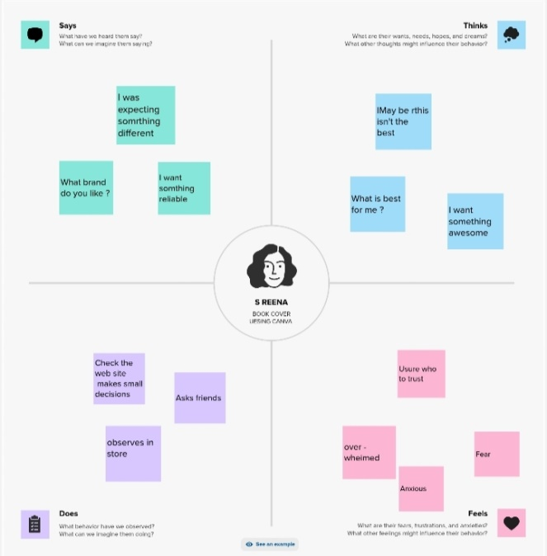

**Brianstroming:**

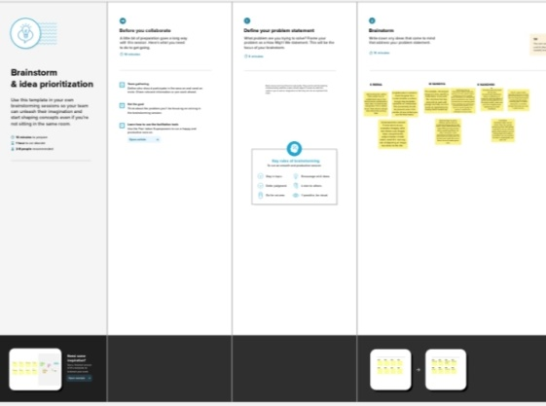

**Result:**



**4.Advantages:**

A well-designed cover can make a book stand out in a croweded marketplace,and can help establish and author’s brand.A book’s cover and it’s content should be inextricably linked.A well-designed cover can communicate the book’s content and tone, and can help to attract the right readers.

**Disadvantages:**

Quality unless you have design skills and experience,the quality of your book cover may not meet industry standards,which can hurt your book’s sales potential.**Time consuming:**Designing a book cover can be time-consuming,especially if you don’t have prior experience or design skills.

**Application:**

This application is accessible.This helps to create our dream design into real.

**6.conclusion:**

Using these applications we are able to get so many features to develop out dream design into many formats.